ARITHMETIC OPERATORS
[ +, -, *, %, / ]
They are used to perform mathematical operations.
Eg:
a+b, a-b, a*b,….
% - Modulus [ Remainder ]:
5%2=1
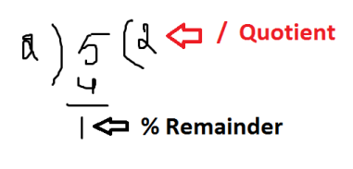2 % 5 = 2
Note: if the divisor is bigger than dividend then dividend is the answer.
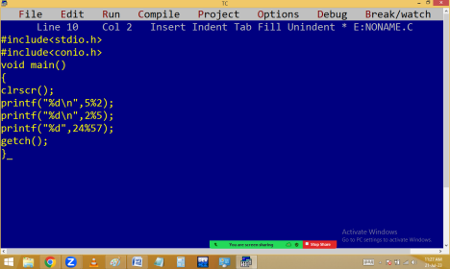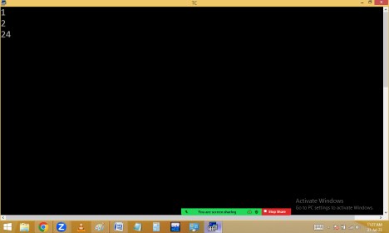
5.0 % 2.0 = Error
Note: We can’t perform floating modulus in c & c++ using % operator. For this we have to use the predefined function fmod() available in <math.h>
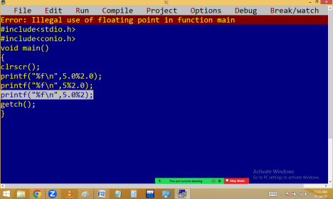
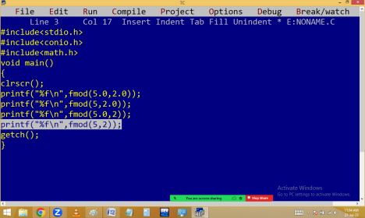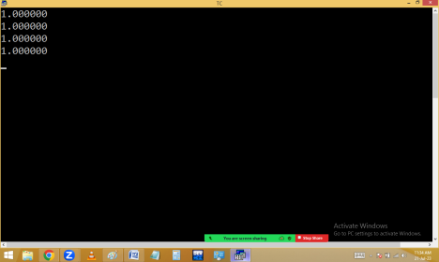341%10=1
34%10=4
3%10=3
Note: Any no%10 gives last digit.
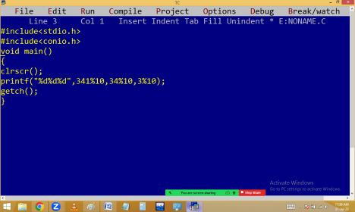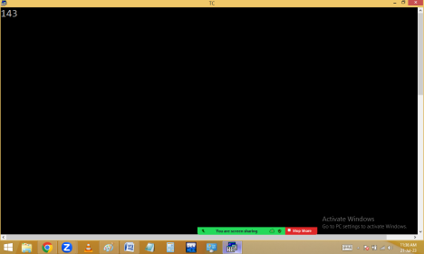
-5%2= -1
5%-2= 1
-5%-2= -1
Note: If numerator is negative then answer also negative.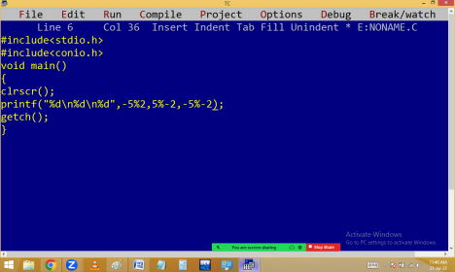
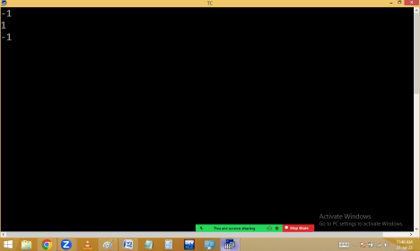/ - division [ Quotient ]:
5/2=2 [ int/int=int ]
5.0/2=2.500000
5/2.0=2.500000
5.0/2.0=2.500000
(float)5/2=2.500000 [ explicit type casting ]
int a=1.2; 🡺 1 🡺 [ implicit type casting ]
float b=10; 🡺 10.00000 🡺 [ implicit type casting ] 5/(float)2=2.500000
(float)(5/2)=2.000000
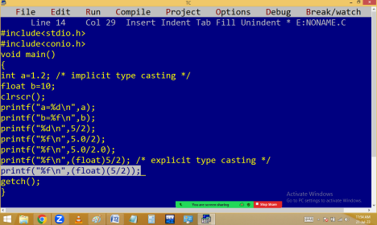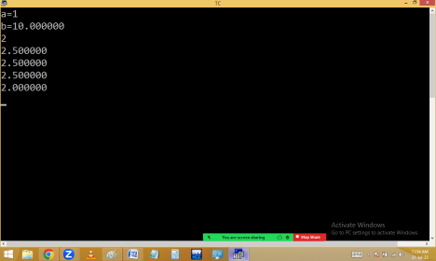123/10=12
12/10=1
1/10=0
Note: Any no/10 removes last digit.
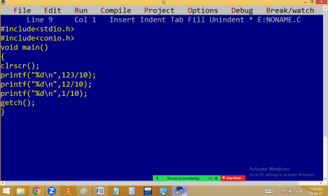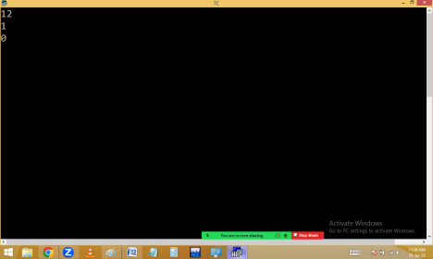
Eg. write a program to print a 3 digit no in reverse order. Eg: 123 reverse is 321
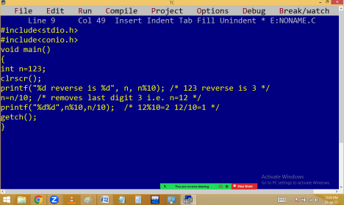
-5 / 2 = -2
5 / -2 = -2
-5 / -2 = 2
Note: In division any one operand is negative then result also negative. Both are negative then result is positive.
RELATIONAL OPERATORS
[ == ( comparison), <, >, <=, >=, != (not equal) ]
They are used to check the given expression or condition is true or false. If condition true always it return 1. If condition false always it return 0.
Operator precedence
(PRIORITY OF OPERATORS)
1. ()
2. +, - , ! (sign operators, unary operators) 3. ++, -- (pre increment & decrement) 4. *, / , %
5. +, - (Binary)
6. = =, !=
7. &&
8. ||
9. ? : (ternary operator)
10. =
11. ++, -- ( Post increment & decrement ) 12. , (comma)

